Variable Assignment & Declaration

A variable is a piece of computer memory with a name and a **type** which stores a **value**. Here is a variable **declaration**:

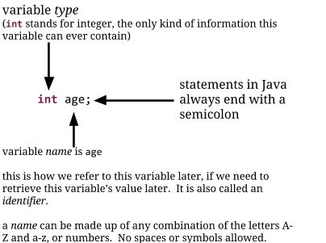

Java code that you write must follow certain rules in order to be acceptable as a computer program. If you follow all the rules, this is called correct syntax. Lines that do not follow the rules are incorrect syntax, and will cause an error.

The diagram above shows you the syntax for variable declaration for a variable of type int. We will learn about other variable types soon.

# Exercise 1. Variable Declarations

Circle which of the following lines is correct syntax for declaring a variable of type int. Put an X over those that use incorrect syntax.

int age;

int ageeeeeeee;

int age

int age;

int thisIsAReallyLongVariableName;

int;

int my age;

int my.age;

int "age";

int my;age;

int my;age;

int; hello;

int hello;

# Exercise 2. Examples of Variable Declarations

Write down the code that tells Java to declare an int variable with the name of "color" (don't include the quotation marks).

Write down the code that tells Java to declare an int variable with the name of "classesPerDay" (don't include the quotation marks).

# Exercise 3. Variable Assignment

We can assign a variable (called an assignment) by using the equals = sign.

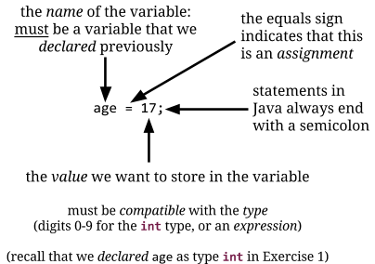

For the integer (int) type, the value must be either a number (digits 0-9 only), or an arithmetic expression like we learned about earlier.

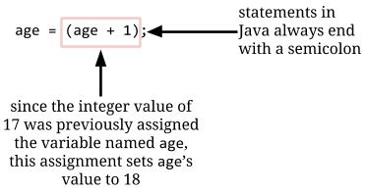

Which of the following are correct syntax for assignment for a variable named age (with type int)? Assume that there are no other variables declared. Put a circle around correct assignments, and put an X through incorrect assignments.

age = 17;

age == 17;

age = "seventeen";

age = 17

age = (age + 1);

Age = 17;

age = (Age + 1);

17 = age;

age 17;

age = 20,000;

age = 17.000;

age = $17;

age =;

age is 17;

# Exercise 4. Combined Declaration and Assignment

Java gives programmers a lot of flexibility in how they use variables, to make our lives easier. One way it helps is by allowing us to combine declaration and assignment:

int age = 17;

This is the same as:

int age;

age = 17;

Circle which of the following lines is correct Java syntax for a combined declaration and assignment. Put an X over those that use incorrect syntax.

int age is 17;

int; hello = 5;

int "age" = "17";

int money = $3,000;

int; hello = 5;

int hello = 5;

int ageeeeeeeeeee = 17eeeeeeee;

int h = 0;

int t =;

# Exercise 5. Expressions in Assignments

Variables can be assigned values that are combinations of other variables. We already saw an example like this:

int age = 17;

age = age + 1;

This results in the variable age having the value of 18.

We can use more complicated expressions, and can even refer to other variables:

int age = 17;

int yearsInCollege = 4;

int ageAfterCollege = age + yearsInCollege;

This results in a variable ageAfterCollege set to the integer value 21.

Sometimes it can get very complicated to trace variable values through multiple assignments. Just take it one step at a time, and you'll be able to figure it out!

What are the values of the variables after each of these statements? (Take each question as a group of statements, so each line builds on the next.)

## Problem 5a:

int variableOne = 1;

int variableTwo = 4;

int variableThree = variableOne + variableTwo;

variableOne = variableThree + 2;

At the end:

variableOne = ______________

variableTwo = ______________

variableThree = ______________

## Problem 5b:

int candies = 70;

int studentsInClass = 15;

int candiesPerStudent = candies / studentsInClass;

int candiesLeftOver = candies % studentsInClass;

At the end:

candies = ______________

studentsInClass = ______________

candiesPerStudent = ______________

candiesLeftOver = ______________

## Problem 5c:

int a = 10;

int b = 100;

int c = 1000;

int d = a + b + c;

int e = d - a;

int f = 10 * e;

At the end:

a = ______________

b = ______________

c = ______________

d = ______________

e = ______________

f = ______________

# 

# Exercise 6. The String Type

Another variable type we can use in Java is the String type:

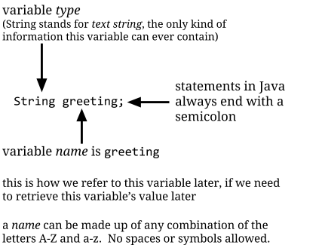

The syntax (or rules) for this are nearly the same as before, except that we put String at the beginning of the line instead of int.

Just like with int, we can combine declaration and assignment:

String greeting = "Hello, world.";

String anotherGreeting = "Hello, " + "world.";

String subway = "Stand clear of the " + "closing doors";

The last two show how + works differently for Strings versus int. Instead of adding two integer values, the + symbol concatenates (smushes together) the Strings. We can also concatenate a String with an int:

String result = "My age is " + age;

This sets the value of result to My age is 17.

Circle which of the following lines is correct Java syntax for declaring a variable of type String. Put an X over those that use incorrect syntax. For those that have correct syntax, write out what the value of the variable will be after the assignment.

String greeting = "Hello, world.";

String greeting = "Hello, world;".

String greeting is "Hello, world.";

String greeting = "Hello, wooooooooorld.";

String "greeting" = "Hello, world.";

String "Hello, world." = greeting;

String myString = "My age is (17 + 1)";

String myString = "My age is " + (17 + 1);

String what'sUp = "How are you?";

String hello = "How are you?"

String hello = "¿Qué tal?";

String goodbye = 'See you later';

Striiiiiiing greeting = "Hello, world.";

String greetiiiiiiing = "Hello, world.";

**Content**

**Debugging Tools**

As you continue to program in Eclipse you will notice some of the debugging tools that are available to you. One of these tools is the syntax colouring whereby syntax errors will be highlighted or underlined a specific colour. This draws the programmer’s attention to h error and allows for quicker fixes.

Even though these tools exist, it is till important for you to get good at identifying syntax and other errors. This will speed up the development process and will result in fewer errors in the final program.

# Exercise 7. Displaying Strings on the Screen

We use statements like the following to display information on the screen:

System.out.println("Hello, world.");

System.out.println("My age is " + 17);

System.out.println("My name is: " + "Barack Obama");

The syntax for this statement looks like this:

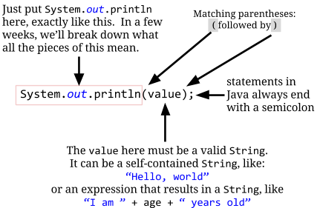

Which of the following are correct syntax for displaying output? (Take each question as a group of statements, so each line builds on the next.)

## Problem 7a.

System.out.println("Hello, world.");

## Problem 7b.

System.out.println("Hello, " + "world.");

## Problem 7c.

System.out.println("Hello, world.);

## Problem 7d.

int myAge = 17;

int yourAge = 16;

System.out.println("My age is " + myAge +

" and your age is " + yourAge +

" and the dog's age is " + dogsAge);

## Problem 7e.

System.out.println("Once upon a time")

## Problem 7f.

System.out.println(Once upon a time);

## Problem 7g.

String g = "Hello, world.";

System.out.println("System.out.println(" + g + ")");

## Problem 7h.

System.out.println(");");

## Problem 7i.

System.out.printn("Hello, world.");

## Problem 7j.

System.oot.println("Hello, world.");

## Problem 7k.

Systeem.out.println("Hello, world.");

## Problem 7l.

System.out..println("Hello, world.");

## Problem 7m.

System.out.println("Hello, world."));

## Problem 7n.

System.out.println("My age is " + age);

int age = 17;